**IOT BASED HOME AUTOMATION SYSTEM**

Final year project report submitted to the department of Computer Science & Engineering in partial fulfilment of the requirements for the Bachelor of Technology

By

Anuj Attri (319021005)

Ritik Thakur (319021007)

Sparsh Guleria (319021003)

Shivali Kapoor (319021009)

*Under the guidance of*

*Er. Shivanshu Katoch*

*Assist. professor*

**Department of computer science and engineering**



**SAI SCHOOL OF ENGINEERING & TECHNOLOGY**

**SRI SAI UNIVERSITY, PALAMPUR**

**176061, District Kangra, Himachal Pradesh**

**CERTFICATE**

*TO WHOM IT MAY CONCERN*

The undersigned certify that they have read and recommended to the Department of Computer Science & Engineering, a final year project work entitled “IOT based Home Automation System” submitted by Anuj Attri, Ritik Thakur, Sparsh Guleria, Shivali kapoor in partial fulfilment of the requirements for the degree of Bachelor of Technology during the academic session 2019-23 and that this project has not submitted previously for the award of any other degree, diploma and fellowship.

***Countersigned by***

**HOD, CSE Department**

**Sri Sai University, Palampur**

**Er. Yamini Sood**

**ACKNOWLEDGEMENT**

We express our sincere gratitude to Prof. Associate Professor, Department of Computer Science & Engineering, as the mentor for our project. It is our great fortune that we have got opportunity to carry out this project work under the supervision. We express our sincere thanks for the encouragement, support and the guidance. We would further like to thank all the faculty member for their cooperation and extended support in undergoing the project work. We also would thank the department of Computer Science & Engineering to provide the infrastructure and facility in carrying the projects like these.

BTech (CSE), 8th Semester

**Sri Sai School of Engineering and technology.**

|  |  |
| --- | --- |
| **CONTENT** | **PAGE NO:** |
| **ABSTRACT………………………………………………………** | 1 |
| **INTRODUCTION……………………………………………….** | 2-6 |
| **LITERATURE REVIEW………………………………………..** | 7-10 |
| **THEORY OF IOT………………………………………………..** | 11-15 |
| **ARDUINO………………………………………………………...** | 16-18 |
| **RELAY……………………………………………………………** | 19-21 |
| **BLUETOOTH MODULE……………………………………….** | 22-34 |
| **FUTURE SCOPE AND CONCLUSION……………………….** | 35-36 |
| **REFRENCES…………………………………………………….** | 37-38 |

**ABSTRACT**

This project presents the overall design of Home Automation System (HAS) with low cost and wireless system. It specifically focuses on the development of an IOT based home automation system that is able to control various components via internet or be automatically programmed to operate from ambient conditions. In this project, we design the development of a firmware for smart control which can successfully be automated minimizing human interaction to preserve the integrity within whole electrical devices in the home. We used Node MCU, a popular open source IOT platform, to execute the process of automation. Different components of the system will use different transmission mode that will be implemented to communicate the control of the devices by the user through Node MCU to the actual appliance. The main control system implements wireless technology to provide remote access from smart phone. We are using a cloud server-based communication that would add to the practicality of the project by enabling unrestricted access of the appliances to the user irrespective of the distance factor. We provided a data transmission network to create a stronger automation. The system intended to control electrical appliances and devices in house with relatively low-cost design, user-friendly interface and ease of installation. The status of the appliance would be available, along with the control on an android platform. This system is designed to assist and provide support in order to 1fulfil the needs of elderly and disabled in home. Also, the smart home concept in the system improves the standard living at home.

**CHAPTER 1**

**INTRODUCTION**

*INTRODUCTION*

Internet of Things (IOT) is a concept where each device is assigned to an IP address and through that IP address anyone makes that device identifiable on internet. The mechanical and digital machines are provided with unique identifiers (UIDs) and the ability to transfer data over a network without requiring human-to-human or human-to-computer interaction. Basically, it started as the “Internet of Computers.” Research studies have forecast an explosive growth in the number of “things” or devices that will be connected to the Internet. The resulting network is called the “Internet of Things” (IoT). The recent developments in technology which permit the use of wireless controlling environments like, Bluetooth and Wi-Fi that have enabled different devices to have capabilities of connecting with each other. Using a WIFI shield to act as a Micro web server for the Arduino which eliminates the need for wired connections between the Arduino board and computer which reduces cost and enables it to work as a standalone device. The Wi-Fi shield needs connection to the internet from a wireless router or wireless hotspot and this would act as the gateway for the Arduino to communicate with the internet. With this in mind, an internet-based home automation system for remote control and observing the status of home appliances is designed.

Due to the advancement of wireless technology, there are several different types of connections are introduced such as GSM, WIFI, and BT. Each of the connection has their own unique specifications and applications. Among the four popular wireless connections that often implemented in HAS project, WIFI is being chosen with its suitable capability. The capabilities of WIFI are more than enough to be implemented in the design. Also, most of the current laptop/notebook or Smartphone come with built-in WIFI adapter. It will indirectly reduce the cost of this system.

*BACKGROUND*

The concept of “Home Automation” has been in existence for several years. “Smart Home”, “Intelligent Home” are terms that followed and is been used to introduce the concept of networking appliance within the house. Home Automation Systems (HASs) includes centralized control and distance status monitoring of lighting, security system, and other appliances and systems within a house. HASs enables energy efficiency, improves the security systems, and certainly the comfort and ease of users. In the present emerging market, HASs is gaining popularity and has attracted the interests of many users. HASs comes with its own challenges. Mainly being, in the present day, end users especially elderly and disabled, even though hugely benefited, aren’t seen to accept the system due to the complexity and cost factors.

*PROJECT OBJECTIVE*

Wireless control of home appliances (switch and voice mode)

To develop the application that would include features of switch and/or voice modes to control the applications.

###### 

Monitoring status of appliances

Being able to view the status of home appliances on the application, in order have a better HAS.

###### 

Secure connection channels between application and node MCU

Use of secure protocols over Wi-Fi so that other devices are prevented to achieve control over the HAS. Secure connections are obtained by SSL over TCP, SSH.

###### 

Controlled by any device capable of Wi-fi (Android, iOS, PC)

To achieve flexibility in control of the home appliances, and device capable of Wi-Fi connectivity will be able to obtain a secure control on the HAS.

Extensible platform for future enhancement

With a strong existing possibility of adding and integrating more features and appliances to the system, the designed system needs to be highly extensible in nature.

*SCOPE*

The aim is to design a prototype that establishes wireless remote control over a network of home appliances. The application is designed to run on android device providing features like, switch mode control, voice command control and a provision to view the status of the devices on the application itself. Considering its wide range of application, following are the scope of this prototype.

The system can be implemented in homes, small offices and malls as well, being in-charge of control of the electrical appliances.

For remote access of appliances in internet or intranet. The appliances in the above-mentioned environment can be controlled in intra-network or can be accessed via internet.

The development of technology friendly environment. The system incorporates the use of technology and making HAS. By the use of day-to-day gadgets, we can utilize them for a different perspective.

*PROJECT MANAGEMENT*

Management of any project can be briefly disintegrated into several phases. Our project has been decomposed into the following phases:

ENVISIONED PHASE

PLANNING PHASE

MODELLING PHASE

CONSTRUCTION

PHASE

DEPLYOMENT PHASE

* Delivery of project
* Feedback
* Coding and hardware assembly
* Testing and Debugging
* Analysis of project
* Design and architecture of project
* Hardware & software estimation
* Scheduling and distribution of task
* Information Gathering
* Project Initiation

Figure 1. Model of phases in project management.

**Experimentation**

This phase involved discussions regarding necessary equipment regarding the project. The study of related already existing projects, gathering required theoretical learning. It also included figuring out the coding part, by developing simple algorithms and flowcharts to design the whole process

**Design**

This phase was, designing layout of the application, and the necessary features to be included. This involved the complete hardware assembly and installing the code to Node MCU. The power strip was designed to connect the home appliances that can be controlled via GPIO pins.

*Development and testing*

This phase had the development of the application. The android device was connected to the Node MCU via wireless network (Wi-Fi) and the whole prototype was tested for identification and removal of bugs.

**Real world Testing**

The prototype was ready to be tested into the real world and integrated with various real time electrical appliances.

*OVERVIEW AND BENEFITS*

The benefits of an established wireless remote switching system of home appliances include:

* No legal issues-Obtaining access to or traversing properties with hard lines is extremely difficult.
* Reduced writing issues-Considering the increase in price of copper, thus increases the possibility of the wire to be stolen. The use of a wireless remote system to control home appliances means no wire for thieves to steal.
* Extended range-As the system establishes control over Wi-Fi, it was a generally considered descent range. That is 150 feet indoors. Outdoors it can be extended to 300 feet, but since the application is of a HAS, an indoor range is considered.
* Security-As the connection of the control of the HAS is established over a secure network the system ensures security to the maximum extent.
* Integrable and extensive nature-The prototype designed can be integrated to a larger scale. Also, it has an extensive nature being able to add or remove the appliances under control according to application.

**CHAPTER 2**

**LITERATURE REVIEW**

***“Smart Energy Efficient Home Automation System using IOT”, by* Satyendra K. Vishwakarma, Prashant Upadhyaya, Babita Kumari, Arun Kumar Mishra.**

This paper presents a step-by-step procedure of a smart home automation controller. It uses IOT to convert home appliances to smart and intelligent devices, with the help of design control. An energy efficient system is designed that accesses the smart home remotely using IOT connectivity. The proposed system mainly requires, Node MCU as the microcontroller unit, IFTTT to interpret voice commands, Adafruit a library that supports MQTT acts as an MQTT broker and Arduino IDE to code the microcontroller. This multimodal system uses Google Assistant along with a web-based application to control the smart home. The smart home is implemented with main controller unit that is connected with the 24-hour available Wi-Fi network. To ensure, that the Wi-Fi connection do not turn off, the main controller is programmed to establish automatic connection with the available network and connected to the auto power backup.

***“IOT Based Smart Security and Home Automation”, by* Shardha Somani, Parikshit Solunke, Shaunak Oke, Parth Medhi, Prof. P. P. Laturkar.**

This paper focuses on a system that provides features of Home Automation relying on IOT to operate easily, in addition to that it includes a camera module and provides home security. The android application basically converts Smartphone into a remote for all home appliances. Security is achieved with motion sensors if movement is sensed at the entrance of the house; a notification is sent that contains a photo of house entrance in real time. This notification will be received by the owner of the house via internet such that app can trigger a notification. So, owner can raise an alarm in case of any intrusion or he/she can toggle the appliances like opening the door if the person is a guest. The system uses Raspberry Pi, a small sized computer which acts as server for the system. The smart home consists two modules. Home automation that consists; fan light and door controller, and security module that consists; smoke sensor motion sensor and camera module.

***“A Dynamic Distributed Energy Management Algorithm of Home Sensor Network for Home Automation System”, by* Tui-Yi Yang, Chu-Sing Yang, Tien-Wen Sung.**

This paper proposes an optimization of home power consumption based on PLC (Power Line Communication) for an easy to access home energy consumption. This also proposes a Zigbee and PLC based renewable energy gateway to monitor the energy generation of renewable energies. ACS and DDEM algorithm are proposed for the design of an intelligent distribution of power management system to make sure ongoing power supply of home networks. To provide efficient power management the power supply models of home sensor network are classified groups viz. main supply only, main supply and backup battery, rechargeable battery power and non-rechargeable battery power. Devices with particular features are assigned to these groups. It targets to establish real time processing scheme to address variable sensor network topologies.

***“Enhance Smart Home Automation System based on Internet of Things”, by* Tushar Churasia and Prashant Kumar Jain.**

This paper proposes a system that develops a model to reduce the computation overhead in existing smart home solutions that uses various encryption technologies like AES, ECHD, hybrid, etc. these solutions use intermediate gateway for connecting various sensor devices. The proposed model provides a method for automation with sensor-based learning. The system uses temperature sensor for development but other sensors can also be used as per requirement. These smart home devices with sensors can configure themselves autonomously and can operate without human intervention. This work minimizes encryption decryption and focuses on authentication and automation of smart home devices with learning. The system bypasses local gateway mentioned in existing system to provide better security for smart home devices and sensor data and save computation overhead. The real time broker cloud is directly connected with smart home and manages all incoming and outgoing request between users and devices. The main purpose to use real time broker cloud is save time of cryptographic operations.

***“Visual Machine Intelligence for Home Automation”, by* Suraj, Ish Kool, Dharmendra Kumar, Shovan Barman.**

The paper presents a vision-based machine intelligence system to sense on/off state of common home appliance. The proposed method of sensing the state of appliances results on a novel home automation system. The accessibility of the suite of devices in the home over a remote network is facilitated by the IP Addressing methods in the IOT. This project uses two boards viz. Raspberry Pi and Intel Galileo Gen 2. The communication between the User devices, Raspberry Pi and the Intel Galileo boards happens over a wireless network. The UDP protocol is deployed to facilitate the wireless communication of the nodes present in the home automation network. A Pi Cam and a USB Logitech camera attached to the rotating shaft of two different servo motor capture snapshots that are passed as inputs to the Machine Learning based models trained using dlib-C++ to detect the state of the operation of the appliances. The proposed method uses visual modality to automate the appliances, as privacy concerns may emerge while using the images from some specific places, as a counter to this issue, an SPDT switch is added to the Raspberry Pi which when turned off ensures that even if the images are taken from the webcams, they are just passed as inputs to the machine learning models and are not displayed on the website when the users access the website on the server address obtained from Raspberry Pi.

***“A Low-Cost Home Automation System Using Wi-Fi based Wireless Sensor Network Incorporating internet of Things”, by* Vikram.N, Harish.K. S, Nihaal.M. S, Raksha Umesh, Shetty Aashik Ashok Kumar.**

This paper illustrates a methodology to provide a low-cost Home Automation System (HAS) using Wireless Fidelity (Wi-Fi). This crystallizes the concept of internetworking of smart devices. A Wi-Fi based Wireless Sensor Network (WSN) is designed for the purpose of monitoring and controlling environmental, safety and electrical parameters of a smart interconnected home. The different sections of the HAS are; temperature and humidity sensor, gas leakage warning system, fire alarm system, burglar alarm system, rain sensing, switching and regulation of load & voltage and current sensing. The primary requirement of HAS to monitor and control of devices is accomplished using a Smartphone application. The application is developed using Android Studio based on JAVA platform and User Interface of those are exemplified. The primary focus of the paper is to develop a solution cost effective flexible in control of devices and implementing a wide range of sensors to to capture various parameters.

***“Voice Controlled Home Automation System using Natural Language Processing and Internet of Things”, by* Mrs. Paul Jasmin Rani, Jason Bakthakumar, Praveen Kumaar.B, Praveen Kumaar.U, Santhosh Kumar.**

The paper focuses on the construction of a fully functional voice-based home automation system that uses Internet of Things, Artificial Intelligence and Natural Language Processing (NLP) to provide a cost-effective, efficient way to work together with home appliances using various technologies such as GSM, NFC, etc. it implements a seamless integration of all the appliances to a central console, i.e., the mobile device. The prototype uses Arduino MK1000, known as Genuine MK1000. The NLP in this project gives the user the freedom to interact with the home appliances with his/her own voice and normal language rather than complicated computer commands. The appliances are connected to the mobile device through an Arduino Board that establishes the concept of Internet of Things. The Arduino Boards are interfaced with the appliances and programmed in such a way that they respond to mobile inputs.

**CHAPTER 3**

**THEORY**

**IOT (INTERNET OF THINGS)**

IOT as a term has evolved long way as a result of convergence of multiple technologies, machine learning, embedded systems and commodity sensors. IOT is a system of interconnected devices assigned a UIDS, enabling data transfer and control of devices over a network. It reduced the necessity of actual interaction in order to control a device. IOT is an advanced automation and analytics system which exploits networking, sensing, big data, and artificial intelligence technology to deliver complete systems for a product or service. These systems allow greater transparency, control, and performance when applied to any industry or system.

**FEATURES OF IOT**

*Intelligence*

IOT comes with the combination of algorithms and computation, software & hardware that makes it smart. Ambient intelligence in IOT enhances its capabilities which facilitate the things to respond in an intelligent way to a particular situation and supports them in carrying out specific tasks. In spite of all the popularity of smart technologies, intelligence in IOT is only concerned as a means of interaction between devices, while user and device interaction are achieved by standard input methods and graphical user interface

*Connectivity*

Connectivity empowers the Internet of Things by bringing together everyday objects. Connectivity of these objects is pivotal because simple object level interactions contribute towards collective intelligence in the IOT network. It enables network accessibility and compatibility in the things.

With this connectivity, new market opportunities for the Internet of things can be created by the networking of smart things and application

*Dynamic nature*

The primary activity of Internet of Things is to collect data from its environment, this is achieved with the dynamic changes that take place around the devices. The state of these devices change dynamically, example sleeping and waking up, connected and/or disconnected as well as the context of devices including temperature, location and speed. In addition to the state of the device, the number of devices also changes dynamically with a person, place and time

*Enormous scale*

The number of devices that need to be managed and that communicate with each other will be much larger than the devices connected to the current Internet. The management of data generated from these devices and their interpretation for application purposes becomes more critical. Gartner (2015) confirms the enormous scale of IOT in the estimated report where it stated that 5.5 million new things will get connected every day and 6.4 billion connected things will be in

*Sensing*

IOT wouldn’t be possible without sensors that will detect or measure any changes in the environment to generate data that can report on their status or even interact with the environment. Sensing technologies provide the means to create capabilities that reflect a true awareness of the physical world and the people in it. The sensing information is simply the analog input from the physical world, but it can provide a rich understanding of our complex world

*Heterogenity*

Heterogeneity in Internet of Things as one of the key characteristics. Devices in IOT are based on different hardware platforms and networks and can interact with other devices or service platforms through different networks. IOT architecture should support direct network connectivity between heterogeneous networks. The key design requirements for heterogeneous things and their environments in IOT are scalabilities, modularity, extensibility and interoperability.

*Security*

IOT devices are naturally vulnerable to security threats. As we gain efficiencies, novel experiences, and other benefits from the IOT, it would be a mistake to forget about security concerns associated with it. There is a high level of transparency and privacy issues with IOT. It is important to secure the endpoints, the networks, and the data that is transferred across all of it means creating a security paradigm.

**Advantages of IOT**

1. *COMMUNICATION*

IOT encourages the communication between devices, also famously known as Machine-to-Machine (M2M) communication. Because of this, the physical devices are able to stay connected and hence the total transparency is available with lesser inefficiencies and greater quality.

1. *AUTOMATION & CONTROL*

Due to physical objects getting connected and controlled digitally and centrally with wireless infrastructure, there is a large amount of automation and control in the workings. Without human intervention, the machines are able to communicate with each other leading to faster and timely output.

1. *INFORMATION*

It is obvious that having more information helps making better decisions. Whether it is mundane decisions as needing to know what to buy at the grocery store or if your company has enough widgets and supplies, knowledge is power and more knowledge is better.

1. *MONITOR*

The second most obvious advantage of IOT is monitoring. Knowing the exact quantity of supplies or the air quality in your home, can further provide more information that could not have previously been collected easily. For instance, knowing that you are low on milk or printer ink could save you another trip to the store in the near future. Furthermore, monitoring the expiration of products can and will improve safety

1. *TIME*

As hinted in the previous examples, the amount of time saved because of IOT could be quite large. And in today’s modern life, we all could use more time.

1. *MONEY*

The biggest advantage of IOT is saving money. If the price of the tagging and monitoring equipment is less than the amount of money saved, then the Internet of Things will be very widely adopted.

IOT fundamentally proves to be very helpful to people in their daily routines by making the appliances communicate to each other in an effective manner thereby saving and conserving energy and cost. Allowing the data to be communicated and shared between devices and then translating it into our required way, it makes our systems efficient.

The IOT allows you to automate and control the tasks that are done on a daily basis, avoiding human intervention. Machine-to-machine communication helps to maintain transparency in the processes. It also leads to uniformity in the tasks. It can also maintain the quality of service. We can also take necessary action in case of emergencies.

**MAIN FEATURES OF PROTOTYPE**

The features of the developed prototype are:

* The prototype establishes a wireless remote switching system of home appliances.
* The prototype uses Wi-Fi to establish wireless control, which gives an indoor range to about 150 feet.
* The command to switch on and off an appliance can be given from radio buttons on the application from one’s smartphone.
* There is also a provision developed to use voice commands on smartphone to remotely switch home appliances
* Any device capable of Wi-Fi connectivity can be used to control the prototype.
* The control over home appliances is obtained over secure connections, by SSL over TCP, SSH.
* Simple design easy to integrate into a verity of appliances and extend on further range.
* Displays the status of each appliances on the application in smartphone

**Project Module**

Project

module

Hardware

module

Software

module

Arduino IDE

4v channel

relay module

9V

battery

LED and

Resistors

Blynk

application

Google

assistant

IFTTT

application

**Chapter 4**

**Arduino**

Arduino is an open-source electronics platform based on easy-to-use hardware and software. Arduino boards are able to read inputs - light on a sensor, a finger on a button, or a Twitter message - and turn it into an output - activating a motor, turning on an LED, publishing something online. You can tell your board what to do by sending a set of instructions to the microcontroller on the board. To do so you use the Arduino programming language (based on Wiring), and the Arduino Software (IDE), based on Processing.

Over the years Arduino has been the brain of thousands of projects, from everyday objects to complex scientific instruments. A worldwide community of makers - students, hobbyists, artists, programmers, and professionals - has gathered around this open-source platform, their contributions have added up to an incredible amount of accessible knowledge that can be of great help to novices and experts alike.

Arduino was born at the Ivrea Interaction Design Institute as an easy tool for fast prototyping, aimed at students without a background in electronics and programming. As soon as it reached a wider community, the Arduino board started changing to adapt to new needs and challenges, differentiating its offer from simple 8-bit boards to products for IoT applications, wearable, 3D printing, and embedded environments.

There are many other microcontrollers and microcontroller platforms available for physical computing. Parallax Basic Stamp, Netmedia's BX-24, Phidgets, MIT's Handyboard, and many others offer similar functionality. All of these tools take the messy details of microcontroller programming and wrap it up in an easy-to-use package. Arduino also simplifies the process of working with microcontrollers, but it offers some advantage for teachers, students, and interested amateurs over other systems:

Inexpensive - Arduino boards are relatively inexpensive compared to other microcontroller platforms. The least expensive version of the Arduino module can be assembled by hand, and even the pre-assembled Arduino modules cost less than \$50

Cross-platform - The Arduino Software (IDE) runs on Windows, Macintosh OSX, and Linux operating systems. Most microcontroller systems are limited to Windows.

Simple, clear programming environment - The Arduino Software (IDE) is easy-to-use for beginners, yet flexible enough for advanced users to take advantage of as well. For teachers, it's conveniently based on the Processing programming environment, so students learning to program in that environment will be familiar with how the Arduino IDE works.

Open source and extensible software - The Arduino software is published as open source tools, available for extension by experienced programmers. The language can be expanded through C++ libraries, and people wanting to understand the technical details can make the leap from Arduino to the AVR C programming language on which it's based. Similarly, you can add AVR-C code directly into your Arduino programs if you want to.

Open source and extensible hardware - The plans of the Arduino boards are published under a Creative Commons license, so experienced circuit designers can make their own version of the module, extending it and improving it. Even relatively inexperienced users can build the breadboard version of the module in order to understand how it works and save money.

**How do I use Arduino?**

See the getting started guide. If you are looking for inspiration you can find a great variety of Tutorials on Arduino Project Hub.

The text of the Arduino getting started guide is licensed under a Creative Commons Attribution-ShareAlike 3.0 License. Code samples in the guide are released into the public domain.

**CHAPTER-5**

**RELAY**

**Definition:**

The relay is the device that open or closes the contacts to cause the operation of the other electric control. It detects the intolerable or undesirable condition with an assigned area and gives the commands to the circuit breaker to disconnect the affected area. Thus protects the system from damage

**Working principle of Relay**

It works on the principle of an electromagnetic attraction. When the circuit of the relay senses the fault current, it energises the electromagnetic field which produces the temporary magnetic field.

[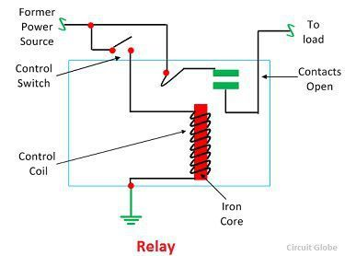](https://circuitglobe.com/wp-content/uploads/2017/01/relay-image.jpg)This magnetic field moves the relay armature for opening or closing the connections. The small power relay has only one contacts, and the high

It works on the principle of an electromagnetic attraction. When the circuit of the relay senses the fault current, it energises the electromagnetic field which produces the temporary magnetic field.

This magnetic field moves the relay armature for opening or closing the connections. The small power relay has only one contacts, and the high-power relay has two contacts for opening the switch.

The inner section of the relay is shown in the figure below. It has an iron core which is wound by a control coil. The power supply is given to the coil through the contacts of the load and the control switch. The current flows through the coil produces the magnetic field around it.

Due to this magnetic field, the upper arm of the magnet attracts the lower arm. Hence close the circuit, which makes the current flow through the load. If the contact is already closed, then it moves oppositely and hence open the contacts.

**Pole and Throw**

The pole and throws are the configurations of the relay, where the pole is the switch, and the throw is the number of connections. The single pole, the single throw is the simplest type of relay which has only one switch and only one possible connection. Similarly, the single pole double throw relay has a one switch and two possible connections.

**Construction of Relay**

The relay operates both electrically and mechanically. It consists electromagnetic and sets of contacts which perform the operation of the switching. The construction of relay is mainly classified into four groups. They are the contacts, bearings, electromechanical design, terminations and housing.

*Contacts –*

The contacts are the most important part of the relay that affects the reliability. The good contact gives limited contact resistance and reduced contact wear. The selection of the contact material depends upon the several factors like nature of the current to be interrupted, the magnitude of the current to be interrupted, frequency and voltage of operation.

*Bearing –*

The bearing may be a single ball, multi-ball, pivot-ball and jewel bearing. The single ball bearing is used for high sensitivity and low friction. The multi-ball bearing provides low friction and greater resistance to shock.

*Electromechanical design –*

The electromechanical design includes the design of the magnetic circuit and the mechanical attachment of core, yoke and armature. The reluctance of the magnetic path is kept minimum for making the circuit more efficient. The electromagnet is made up of soft iron, and the coil current is usually restricted to 5A and the coil voltage to 220V.

*Terminations and Housing –*

The assembly of an armature with the magnet and the base is made with the help of spring. The spring is insulated from the armature by molded blocks which provide dimensional stability. The fixed contacts are usually spot welded on the terminal link.

**CHAPTER 6**

**BLUETOOTH MODULE**

Wireless communication is swiftly replacing the wired connection when it comes to electronics and communication. Designed to replace cable connections HC-05 uses serial communication to communicate with the electronics. Usually, it is used to connect small devices like mobile phones using a short-range wireless connection to exchange files. It uses the 2.45GHz frequency band. The transfer rate of the data can vary up to 1Mbps and is in range of 10 meters.

The HC-05 module can be operated within 4-6V of power supply. It supports baud rate of 9600, 19200, 38400, 57600, etc. Most importantly it can be operated in Master-Slave mode which means it will neither send or receive data from external sources.

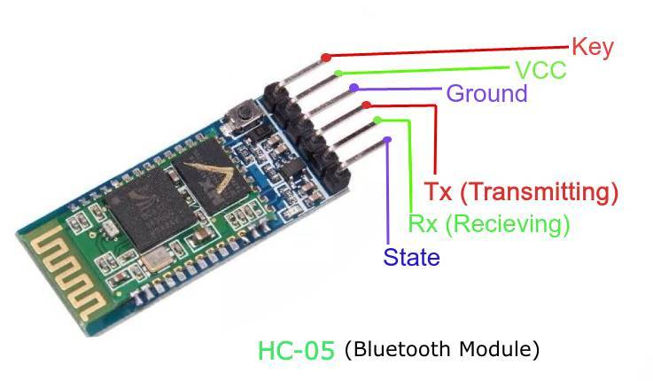

**Description of Pins**

* **Enable - This pin is used to set the Data Mode or and AT command mode (set high).**
* **VCC - This is connected to +5V power supply.**
* **Ground - Connected to ground of powering system.**
* **Tx (Transmitter) - This pin transmits the received data Serially.**
* **Rx (Receiver) - Used for broadcasting data serially over Bluetooth.**
* **State -Used to check if the Bluetooth is working properly.**

**Modes of Operation**

The HC-05 Bluetooth Module can be used in two modes of operation: Command Mode and Data Mode.

*Command Mode*

In Command Mode, you can communicate with the Bluetooth module through AT Commands for configuring various settings and parameters of the Module like get the firmware information, changing Baud Rate, changing module name, it can be used to set it as master or slave.

A point about HC-05 Module is that it can be configured as Master or Slave in a communication pair. In order to select either of the modes, you need to activate the Command Mode and sent appropriate AT Commands.

*Data Mode*

Coming to the Data Mode, in this mode, the module is used for communicating with other Bluetooth device i.e., data transfer happens in this mode.

Programming HC-05 with Microcontroller

Technical specs of the code:

Arduino-Uno is used as the microcontroller.

Name: HC-05

Password: 1234 (or 0000)

Type: Slave

Mode: Data

Baud Rate: 9600 with 8 data bits, no parity and 1 stop bit

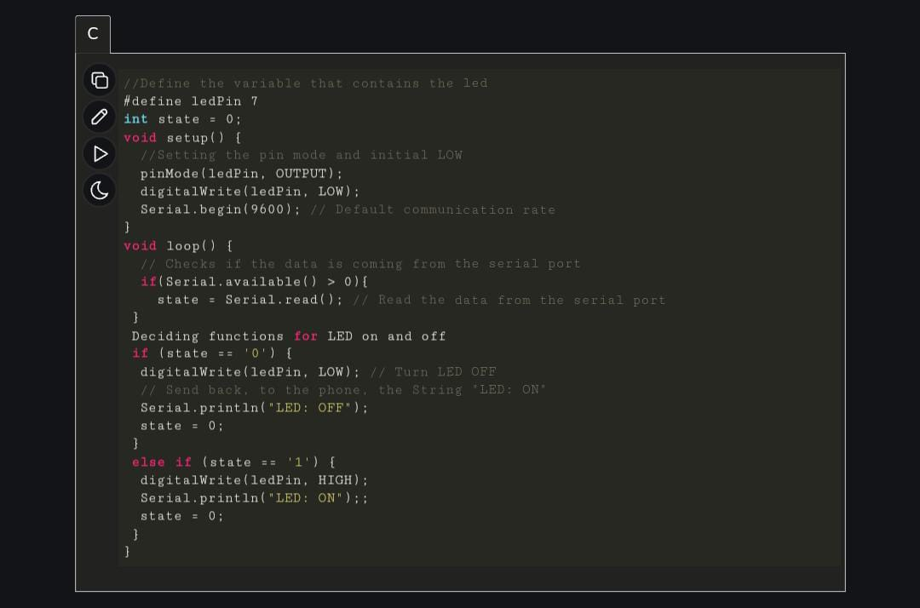

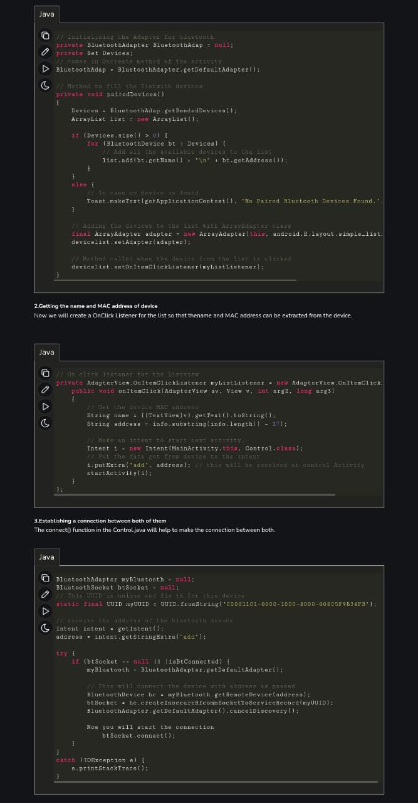

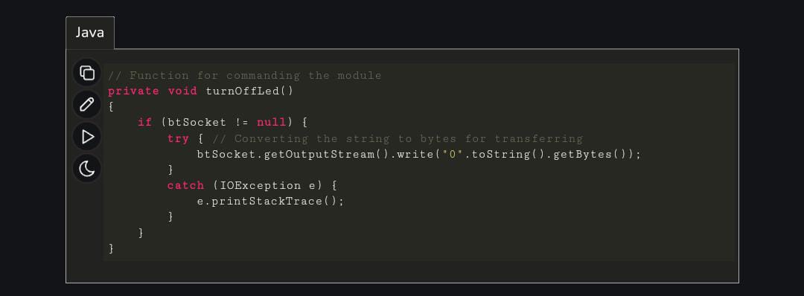

**Where To Use HC05 Module**

The **HC-05** is a popular module which can add two-way (full-duplex) wireless functionality to your projects. You can use this module to communicate between two microcontrollers like Arduino or communicate with any device with Bluetooth functionality like a Phone or Laptop. There are many android applications that are already available which makes this process a lot easier. The module communicates with the help of USART at 9600 baud rate hence it is easy to interface with any microcontroller that supports USART. We can also configure the default values of the module by using the command mode. So if you looking for a Wireless module that could transfer data from your computer or mobile phone to microcontroller or vice versa then this module might be the right choice for you. However do not expect this module to transfer multimedia like photos or songs; you might have to look into the CSR8645 module for that.

**How to use the HC05 Bluetooth Module**

The **HC-05** has two operating modes, one is the Data mode in which it can send and receive data from other Bluetooth devices and the other is the AT Command mode where the default device settings can be changed. We can operate the device in either of these two modes by using the key pin as explained in the pin description.

It is very easy to pair the HC-05 module with microcontrollers because it operates using the Serial Port Protocol (SPP). Simply power the module with +5V and connect the Rx pin of the module to the Tx of MCU and Tx pin of module to Rx of MCU as shown in the figure below

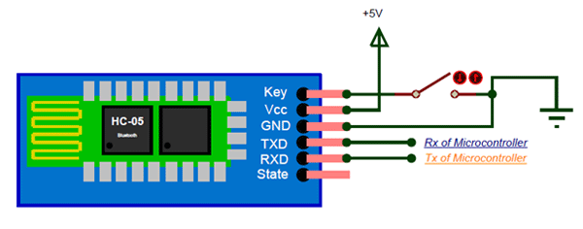

During power up the key pin can be grounded to enter into Command mode, if left free it will by default enter into the data mode. As soon as the module is powered you should be able to discover the Bluetooth device as “HC-05” then connect with it using the default password 1234 and start communicating with it. The name password and other default parameters can be changed by entering into the

**Applications**

1. Wireless communication between two microcontrollers

2. Communicate with Laptop, Desktops and mobile phones

3. Data Logging application

4. Consumer applications

5. Wireless Robots

6. Home Automation

**2D MODEL**

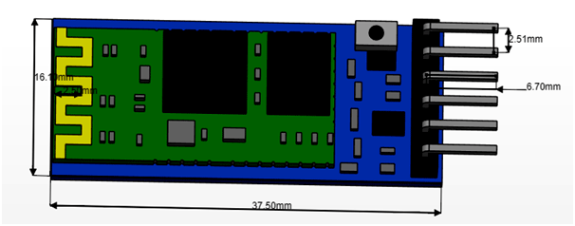

Generally, jumpers are tiny metal connectors used to close or open a circuit part. They have two or more connection points, which regulate an electrical circuit board. Their function is to configure the settings for computer peripherals, like the motherboard. Suppose your motherboard supported intrusion detection. A jumper can be set to enable or disable it. Jumper wires are electrical wires with connector pins at each end. They are used to connect two points in a circuit without soldering. You can use jumper wires to modify a circuit or diagnose problems in a circuit. Further, they are best used to bypass a part of the circuit that does not contain a resistor and is suspected to be bad. This includes a stretch of wire or a switch. Suppose all the fuses are good and the component is not receiving power; find the circuit switch. Then, bypass the switch with the jumper wire.

How much current (I) and voltage (V) can jumper wires handle? The I and V rating will depend on the copper or aluminium content present in the wire.For an Arduino application is no more than 2A and 250V. We also recommend using solid-core wire, ideally 22 American Wire Gauge (AWG).

*Jumper Wire Colours*

Although jumper wires come in a variety of colours, they do not actually mean anything. The wire colour is just an aid to help you keep track of what is connected to which. It will not affect the operation of the circuit. This means that a red jumper wire is technically the same as the black one. Even so, the colours can be used to your advantage to differentiate the types of connections. For instance, red as ground and black as power. Literally, what works for you!

Types of Jumper Wires

Jumper wires come in three versions:

* Male-to-male jumper
* Male-to-female jumper
* Female-to-female jumper

And two types of head shapes: square head and round head.

The difference between each is in the endpoint of the wire. Male ends have a pin protruding and can plug into things, while female ends do not but are also used for plugging.

Moreover, a male connector is referred to as a plug and has a solid pin for centre conduction. Meanwhile, a female connector is referred to as a jack and has a centre conductor with a hole in it to accept the male pin.

Male-to-male jumper wires are the most common and what you will likely use most often. For instance, when connecting two ports on a breadboard, a male-to-male wire is what you will need.

*Alligator clips*

Alligator clips are the ‘fancy’ versions of jumper wires. They consist of two spring metal clips connected by wire. Their unique connection point allows alligator clips to be used in situations where it is tricky for a regular jumper wire. One of their most common uses is connecting the ports on a Lilypad Arduino board. If you want to get fancier, it is possible to get jumper wires with a male pin connection on one end and an alligator clip on the other.

*How to choose a jumper wire?*

Now that you know the three types of jumper wires and their functions, you should be able to which head type to use. This also includes the head shape, though it may depend on the head type you have. For instance, you are connecting an Arduino Uno pin with a breadboard. A male-to-male jumper is recommended. But if you are connecting it directly to an Ultrasonic Sensor, go for a male-to-female jumper.

*Jumper Wires and Soldering*

Can jumper wires be soldered? Yes, as long as the soldered wires are discernible on the opposite side. Like a through-hole component lead, the outline of the wire in the solder connection should be visible. Jumper wire soldered to lifted or clipped components should also be insulated. This is to prevent shorting occurrences.

*How do you solder a jumper?*

* First step: Strip the wire, then open the strippers.
* Second step: Tin the wire.
* Third step: Solder the jumper to the board. Poke your tinned jumper end through your PC board.
* Fourth step: Clip the excess. Set your cutters close to the base of the wire.
* Fifth step: Desolder the joint.

*How to Use Jumper Wires*

Jumper wires are great for modifying a circuit or diagnosing problems in a circuit. The following steps show you how to use these wires in different applications safely.

* Step 1-Your first step is to follow electrical safety precautions. Be cautious, especially when dealing with high-voltage circuits. But even with low-voltage circuits, you still need to be attentive.
* Step 2-Know the suitable type of connector for the jumper wire. In some cases, you can use the bare wire ends to connect two circuit points. This is recommended if you have steady hands.
* Step 3-Use the jumper wire to bypass part of the circuit or establish a connection between two points. This helps determine if a part of the circuit is faulty or broken.
* Step 4-Connect the jumper wire to a voltmeter or ammeter for circuit property measurements. This allows you to get numbers between or across two points.
* Step 5-Choose the right type of jumper wire if you are making a permanent modification to a circuit. The gauge and type of insulation are also essential considerations.
* Step 6-Test circuit modifications with a temporary jumper wire before making a permanent connection. You can do this with solder.

**Relay 4 Channel**

The **four-channel relay module** contains four 5V relays and the associated switching and isolating components, which makes interfacing with a microcontroller or sensor easy with minimum components and connections. The contacts on each relay are specified for 250VAC and 30VDC and 10A in each case, as marked on the body of the relays.

*Four Channel Relay module pinout*

|  |  |  |
| --- | --- | --- |
| **Pin Number** | **Pin Name** | **Description** |
| 1 | GND | Ground reference for the module |
| 2 | IN1 | Input to activate relay 1 |
| 3 | IN2 | Input to activate relay 2 |
| 4 | IN3 | Input to activate relay 3 |
| 5 | IN4 | Input to activate relay 4 |
| 6 | VCC | Power supply for the relay module |
| 7 | VCC | Power supply selection jumper |
| 8 | JD-VCC | Alternate power pin for the relay module |

*Components present on a 4 channel Relay module*

Following are the major components present on the four-channel relay module, we will get into the details of this later in the article.

[5V relay](https://components101.com/5v-relay-pinout-working-datasheet), terminal blocks, male headers, [transistors](https://components101.com/transistors), [optocouplers](https://components101.com/optocouplers), [diodes](https://components101.com/diodes), and [LEDs](https://components101.com/tags/led).

*Four channel Relay module specialization*

* Supply voltage – 3.75V to 6V
* Trigger current – 5mA
* Current when the relay is active - ~70mA (single), ~300mA (all four)
* Relay maximum contact voltage – 250VAC, 30VDC
* Relay maximum current – 10A

### **CHAPTER 7**

### **FUTURE SCOPE AND CONCLUSION**

### *RESULT*

The experimental model was made according to the circuit diagram and the results were as expected. The home appliances could be remotely switched over Wi-Fi network. Both the switch mode and the voice mode control methodologies were successfully achieved. The Blynk application was also successful in displaying the status of every application.

### *LIMITATIONS*

Android devices having lower API version than 16 requires internet access to convert the speech data to string data. Currently, the application is made for Android Smart Phones; other OS platform doesn’t support our application. During voice mode, external noises (voice) may affect our result. The speech instruction that we command in our voice mode may not give exact result as expected. There hence lies an ambiguity in result.

### *FURTHER ENHANCEMENT AND FUTURE SCOPE*

Looking at the current situation we can build cross platform system that can be deployed on various platforms like iOS, Windows. Limitation to control only several devices can be removed by extending automation of all other home appliances. The prototype can include sensors to implement automatic control of the home appliances like; an LDR that can sense daylight and switch lamp accordingly, a PIR to detect motion and be used for security purposes making an alarm buzz, or a DHT11 sensor that’s senses ambient temperature and humidity of atmosphere and switch fan/air conditioner accordingly. Scope of this project can be expanded to many areas by not restricting to only home, but to small offices

### *CONCLUSION*

It is evident from this project work that an individual control home automation system can be cheaply made from low-cost locally available components and can be used to control multifarious home appliances ranging from the security lamps, the television to the air conditioning system and even the entire house lighting system. The designed home automation system was tested a number of times and certified to control different home appliances used in the lighting system, air conditioning system, home entertainment system and many more. Hence, this system is scalable and flexible.

### **CHAPTER 7**

### **REFRENCES**

1. “Smart Energy Efficient Home Automation System using IOT”, by Satyendra K. Vishwakarma, Prashant Upadhyaya, Babita Kumari, Arun Kumar Mishra.
2. “IOT Based Smart Security and Home Automation”, by Shardha Somani, Parikshit Solunke, Shaunak Oke, Parth Medhi, Prof. P. P. Laturkar.
3. “A Dynamic Distributed Energy Management Algorithm of Home Sensor Network for Home Automation System”, by Tui-Yi Yang, Chu-Sing Yang, Tien-Wen Sung; in 2016 Third International Conference on Computing Measurement Control and Sensor Network.
4. “Enhance Smart Home Automation System based on Internet of Things”, by Tushar Churasia and Prashant Kumar Jain; in Proceedings of the Third International Conference on I-SMAC (IoT in Social, Mobile, Analytics and Cloud) (I-SMAC 2019) IEEE Xplore Part Number:CFP19OSV- ART; ISBN:978-1-7281-4365-1
5. “Visual Machine Intelligence for Home Automation”, by Suraj, Ish Kool, Dharmendra Kumar, Shovan Barman.
6. “A Low Cost Home Automation System Using Wi-Fi based Wireless Sensor Network Incorporating internet of Things”, by Vikram.N, Harish.K.S, Nihaal.M.S, Raksha Umesh, Shetty Aashik Ashok Kumar; in 2017 IEEE 7th International Advance Computing Conference.
7. “Voice Controlled Home Automation System using Natural Language Processing and Internet of Things”, by Mrs. Paul Jasmin Rani, Jason Bakthakumar, Praveen Kumaar.B, Praveen Kumaar.U, Santhosh Kumar; in 2017 Third International Conference on Science Technology Engineering & Management (ICONSTEM)
8. Wikipedia(2009). HomeAutomation. From https://en.wikipedia.org/wiki/Home_automation
9. Theory of IOT from :https://internetofthingsagenda.techtarget.com/definition/Internet-of-Things-IoT
10. About ARDUINO from: https://lastminuteengineers.com/esp8266-nodemcu-arduino-tutorial/